**Name – Davender Singh**

**Student ID – \*\*\*\*\*\*\*\*\*\***

**Course – CCP555NSA**

**Professor – David Humphrey**

**Lab 5**

Links to fragments microservice's Dockerfile and .dockerignore files on GitHub:

<https://github.com/davender-singh1/fragments/blob/main/Dockerfile>

<https://github.com/davender-singh1/fragments/blob/main/.dockerignore>

Screenshot of fragments microservice running as a Docker container in detached mode. Use port 5555 on your host and port 8080 in the container:

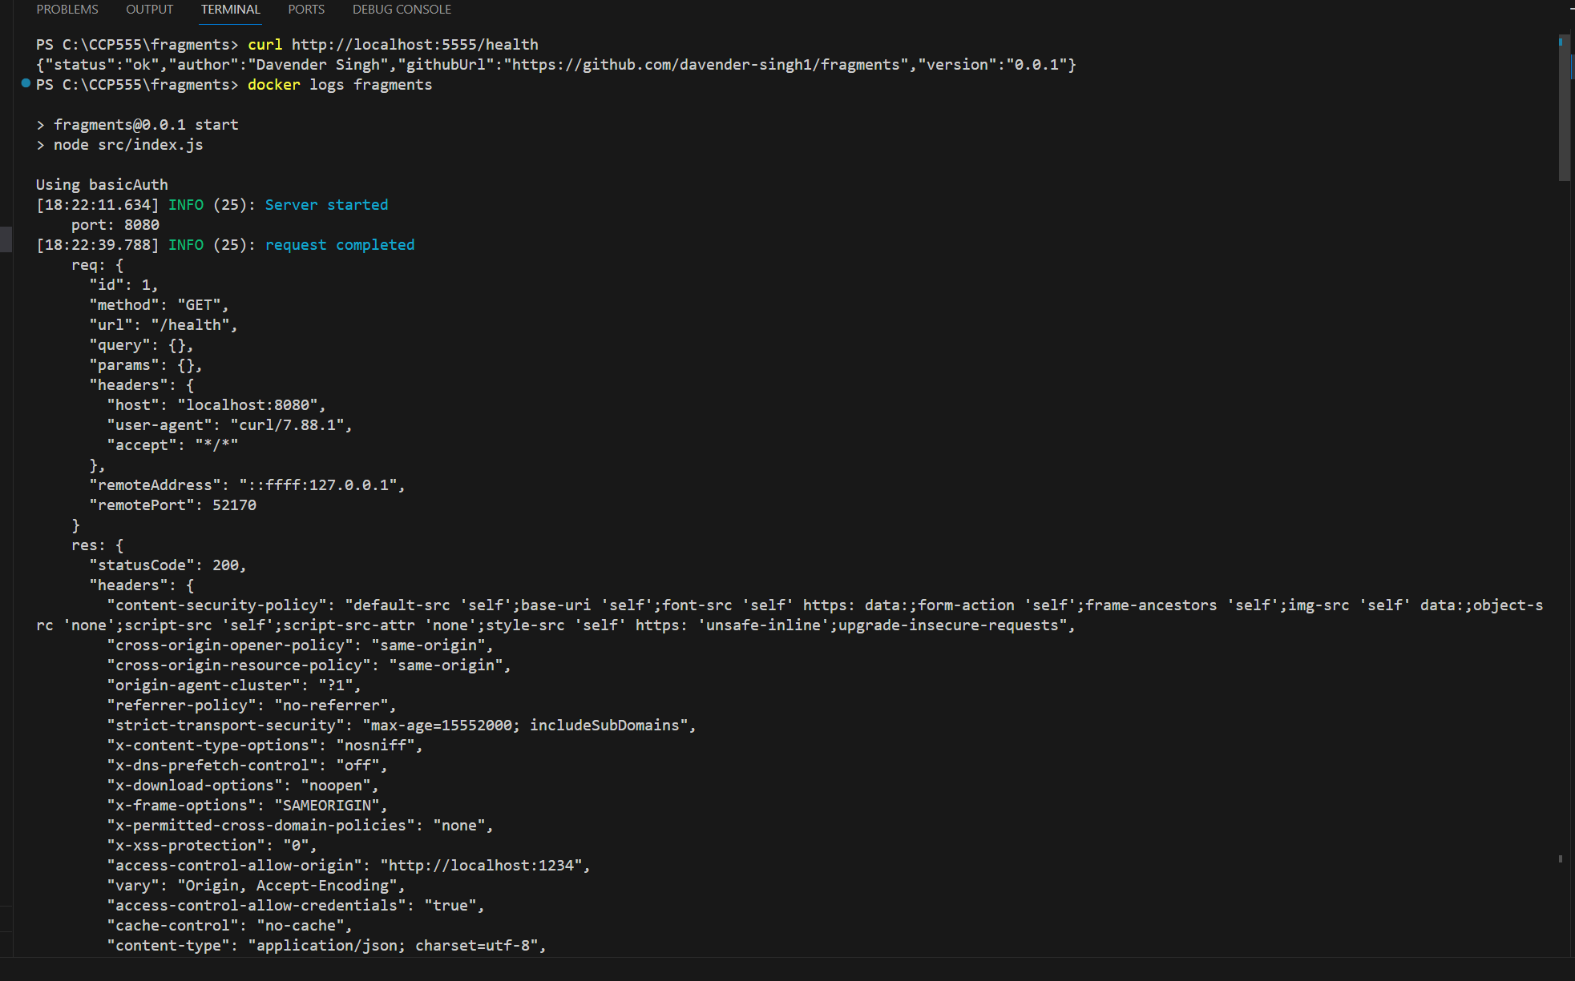

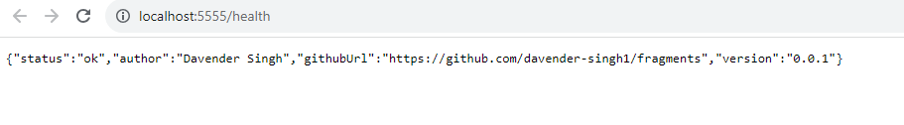

Screenshot of your fragments microservice container running in Visual Studio Code via the Docker Extension. Right-click it and include the logs:

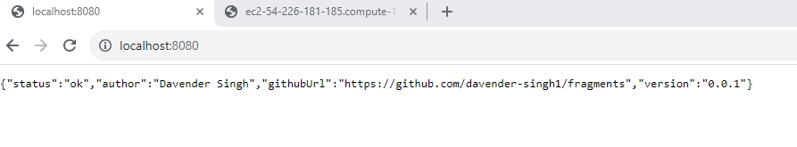

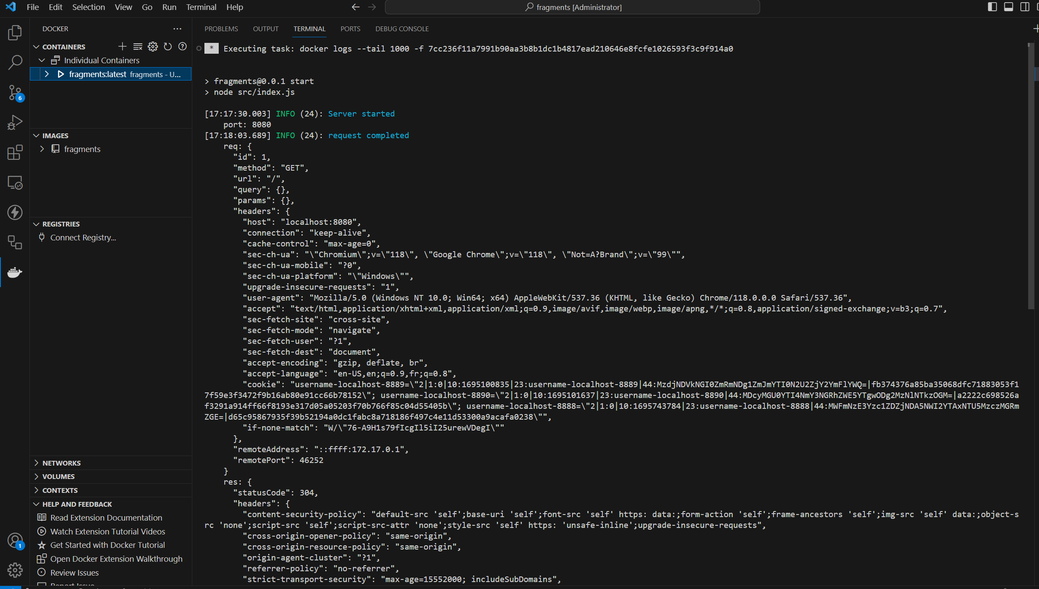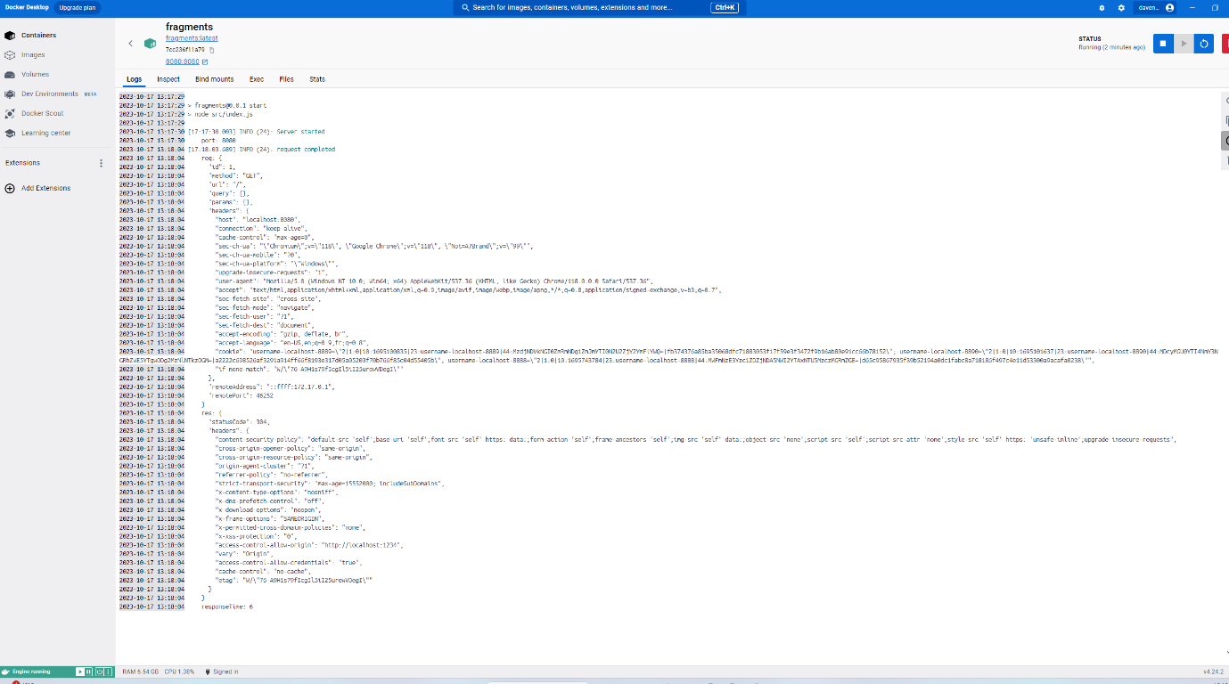

Screenshots of your fragments microservice running as a Docker container in **detached** mode on EC2. Use port 8080 on your EC2 host and port 8080 in the container:

